Navigating the EVV Provider Dashboard

To better understand your claim lines status, visit ODM’s EVV Provider Dashboard. This dashboard is designed to support providers in evaluating paid claims that cannot be validated against EVV data. It does not provide specific information about each invalid claim or the gap in the matched data. The dashboard will be updated to include each service subject to validation 2-3 months prior to enforcing new claim validation requirements.

Navigating the EVV Provider Dashboard Homepage

Step 1: Click here to access the EVV Provider Dashboard homepage.

Step 2: Select the page that you would like to go to. The Definitions Page provides information on the terminology used in the dashboards. The Provider Lookup Dashboard SFY24 produces a report showing claim lines submitted and paid from July 2023 to June 2024 that may be missing complete EVV data. Similarly, the Provider Lookup Dashboard SFY25 produces a report showing claim lines submitted from July 2024 with a paid date after October 16, 2024, through the latest date indicated on the dashboard. Lastly, the Error Diagnostic Dashboard SFY25 shows the errors associated with paid claim lines and shows dollar figures associated with specific errors.

Features to Note:

- This dashboard is being routinely updated by the ODM data team. The date that the dashboard was last published can be found in the lower-left corner of the dashboard homepage, as indicated by the orange arrow in the screenshot below.
- Hover over the blue information icons next to the dashboard buttons to receive additional information about the data available on each view and the kinds of questions that the view can answer.

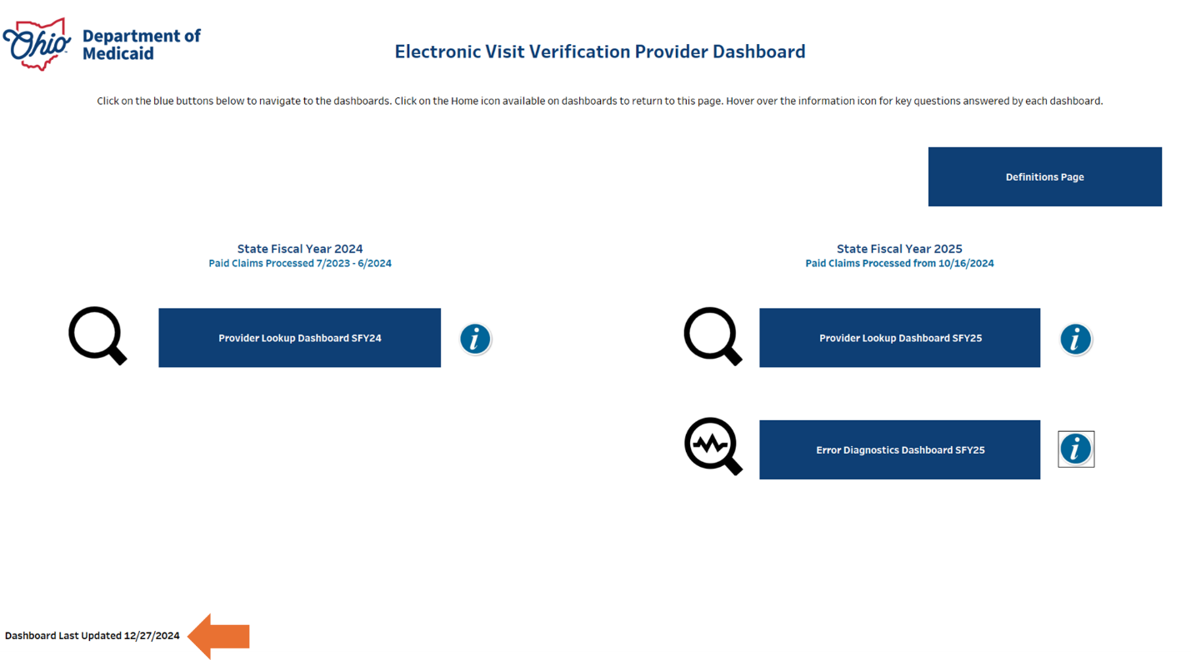

Navigating the Provider Lookup Dashboards Instructions:

The following instructions apply to both the SFY24 and SFY25 dashboards, with differences noted where applicable.

As you are utilizing the dashboards, please note the following:

- The SFY24 dashboard contains claims data with paid dates and dates of service (DOS) from July 2023 – June 2024. As of 11/22/2024, the SFY24 dashboard was updated to only include paid claims with a date of service after July 2023. Claims paid in the processing period with a DOS before July 2023 will not appear. If you reviewed the dashboard prior to 11/20, you may see a reduced number of claim lines due to the removal of services performed prior to July 2023.

- The SFY25 dashboard contains data with dates of service from July 2024 forward with paid dates after October 16, 2024. The maximum paid date reflected in the data can be found by hovering over the information icon on the top right of the dashboard.

Step 1: Click on the Provider Lookup Dashboard SFY24 or SFY25 button on the homepage.
Step 2: Type your 7-digit provider Medicaid ID number into the “Enter Medicaid ID” box, indicated by the black arrow in the image below, and then hit “enter”. If you do not know your Medicaid ID number, please access the Provider Network Management (PNM) Module by clicking where indicated by the orange arrow in the image below or visiting the PNM Module here.
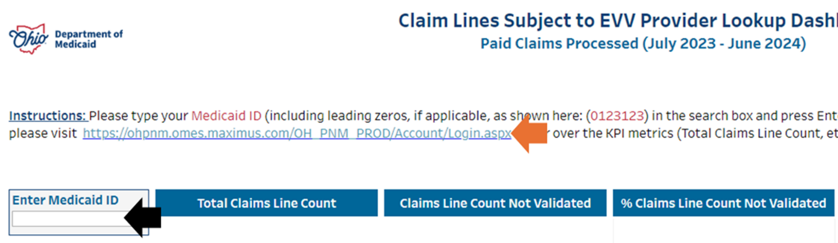

Step 3: Once you have entered your provider Medicaid ID number, the dashboard will produce a report showing the paid claim lines you submitted that are missing complete EVV data. This can be found in the “Percent (%) Claim Lines Not Validated” column. Higher percentages indicate larger volumes of claim lines that are experiencing error. As a provider, your goal should be to have as low a percentage in this field as possible.

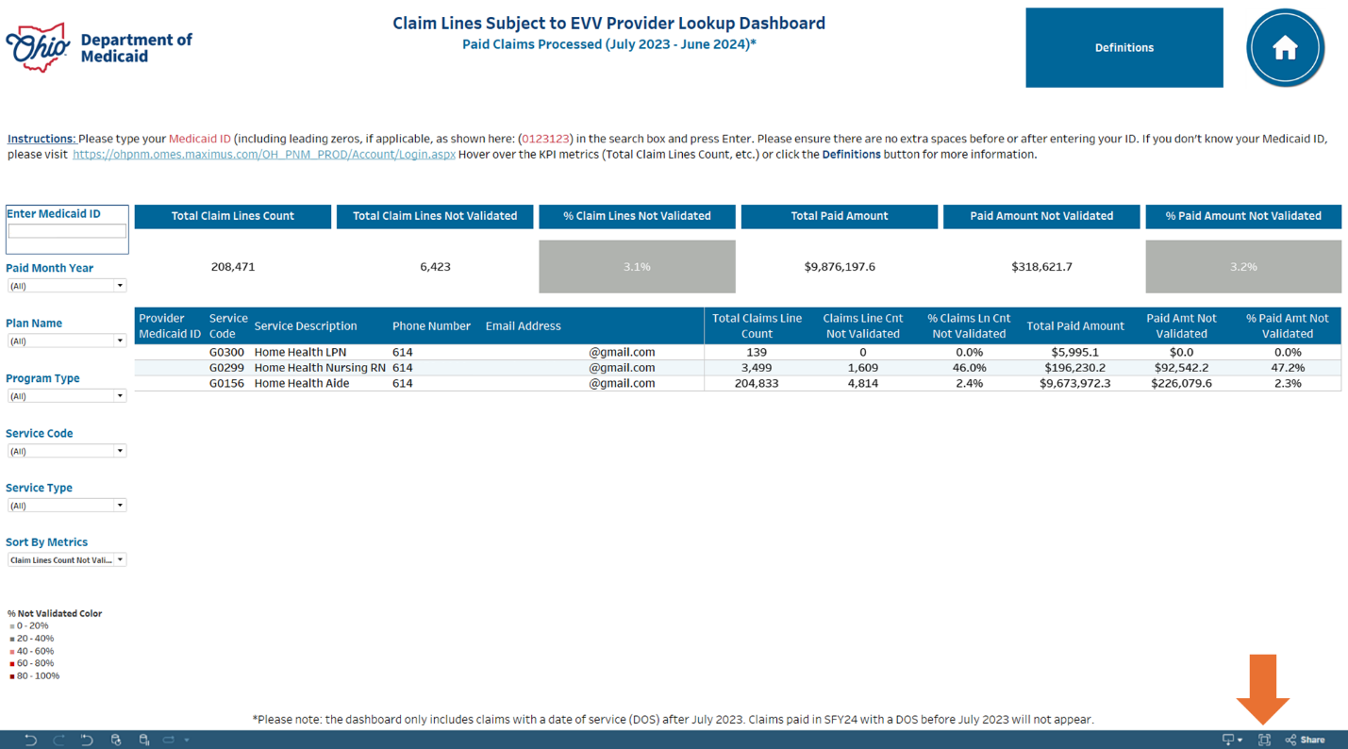
Please Note: If you are having issues reading the data on the page due to your device’s screen resolution, there are several ways to make the data more readable. Utilize the fullscreen button indicated by the orange arrow in the image above or utilize the zoom out functionality of your web browser, as shown with black arrows in the images below.

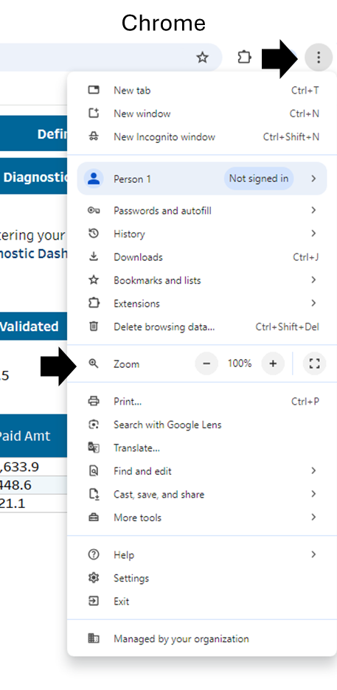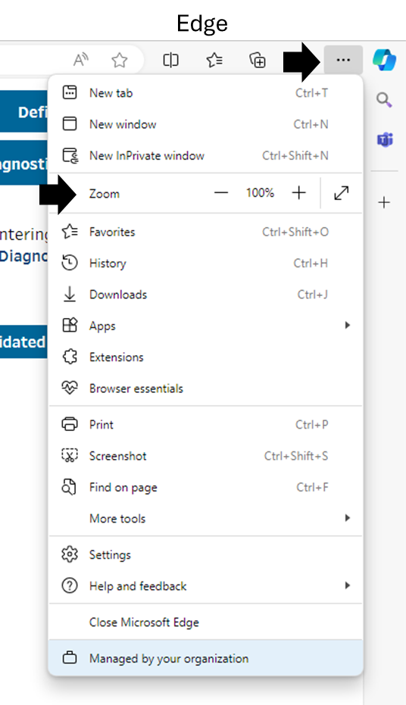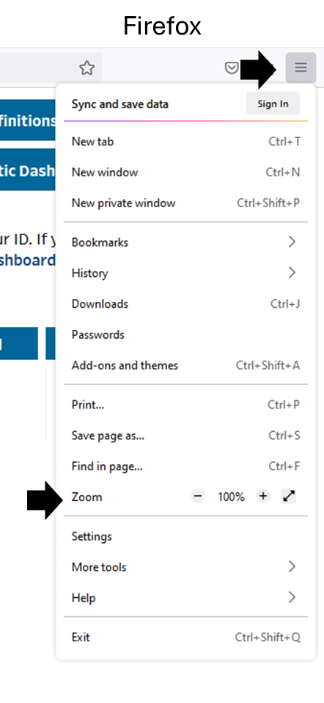

Step 4 (Optional): Refine and sort the results of your report by using the filters to the right of the data.

- The Paid Month Year filter available only on the SFY24 dashboard allows you to select and deselect certain paid months.
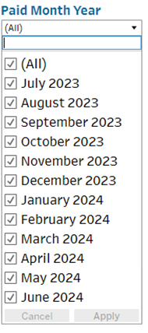
- Similarly, the Week of Service filter available only on the SFY25 dashboard allows you to select and deselect certain weeks where you were providing services.
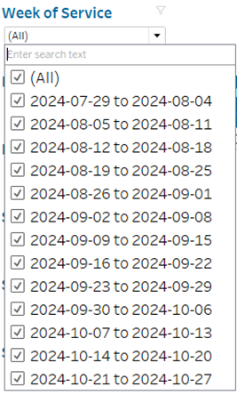
- The Service Code and Service Type filters allow you to search by specific services rendered in the claim line.
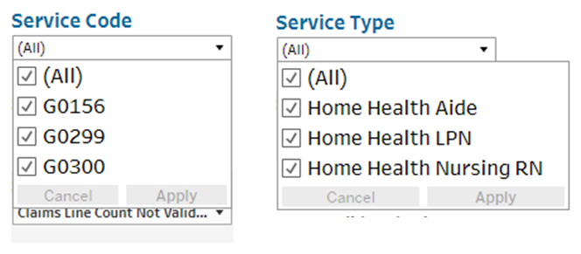

- Lastly, you can sort the results of your report by any of the KPI metrics by selecting them in the Sort By Metrics filter.
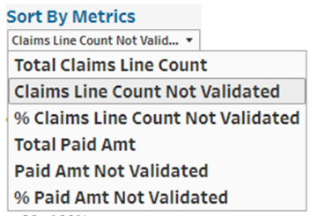

Additional Features to Note:
- You can utilize the navigation buttons on the dashboard to return to the home page (yellow arrow) or navigate to the definitions page (orange arrow). On the SFY25 page, you can also navigate directly to the Diagnostic Dashboard (SFY25).
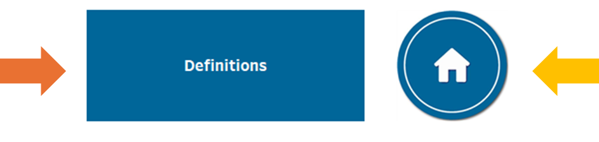
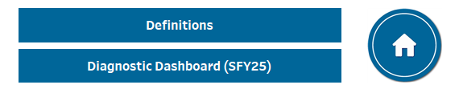
- You can hover over the KPI metrics (Total Claims Line Count, etc.) to receive additional information about the KPIs and how they are calculated.
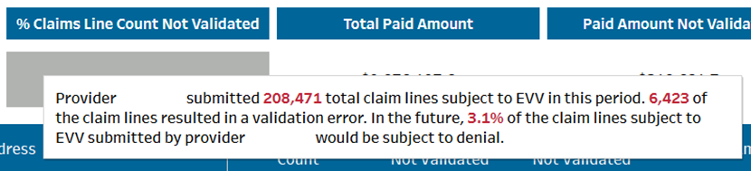

Navigating the EVV Error Diagnostic Dashboard (SFY25) Instructions:

As you are utilizing the dashboard, please note the following:
- The EVV Error Diagnostic Dashboard SFY25 contains data with dates of service from July 2024 forward with paid dates after October 16, 2024. The maximum paid date reflected in the data can be found by hovering over the information icon on the top right of the dashboard.
Step 1: Click on the Error Diagnostics Dashboard button from the homepage.

Step 2: Type your 7-digit provider Medicaid ID number into the “Enter Medicaid ID” box, indicated by the black arrow in the image below, and then hit “enter”. If you do not know your Medicaid ID number, please access the Provider Network Management (PNM) Module by clicking where indicated by the orange arrow in the image below or visiting the PNM Module here.

Step 3: Once you have entered your Medicaid ID number, the dashboard will produce a report showing the claim lines, dollar figures, and service codes associated with specific EVV errors. Descriptions of the EVV errors can be found on the Definitions page. Review the information on the report to determine the volume of claim lines and paid amounts that will be subject to error when EVV rules go into effect.

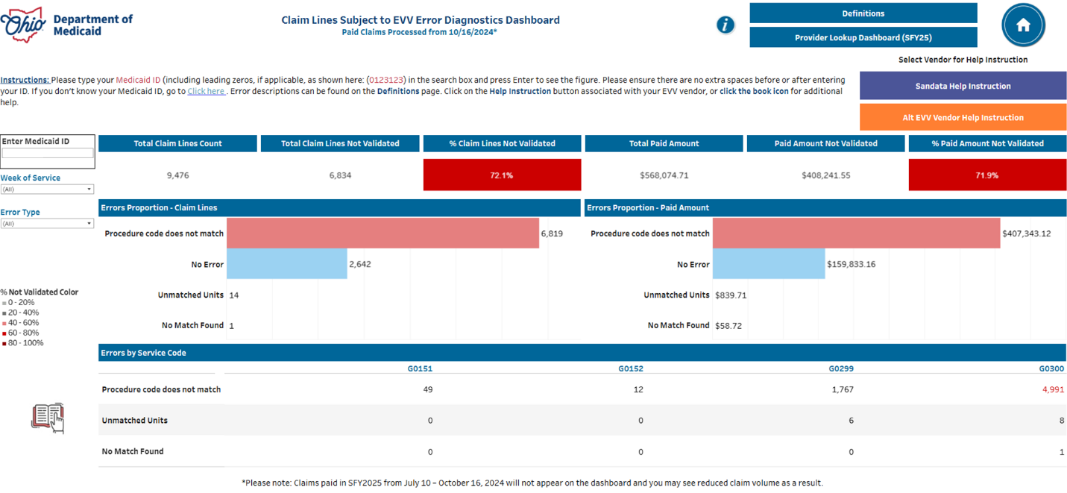
Step 4 (optional): Refine the results of your report by utilizing the filters.
- The Week of Service filter allows you to select and deselect certain weeks where you were providing services.
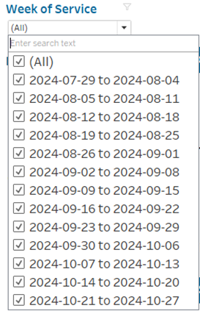

- The Error Type filter allows you to select specific error(s) and filter the report elements to focus on the selected error(s).
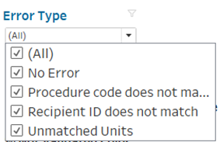

Step 5: Select a Vendor Type for Help Instruction. Once you have reviewed your claim line errors, you can receive information on how to correct these errors by selecting your EVV vendor in the upper left of the dashboard. If you utilize Sandata, please click the “Sandata Help Instruction” button. If you utilize a vendor that is not Sandata, please click the “Alt EVV Help Instruction” button.
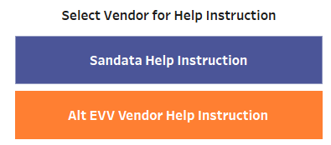

Step 6: Depending on which EVV provider you selected in step 5, you will be taken to a help instruction page with guidance on how to correct common EVV errors. Please utilize the scroll bars on the right side of the screen, indicated by the orange arrows in the below screenshots, to view all the text.
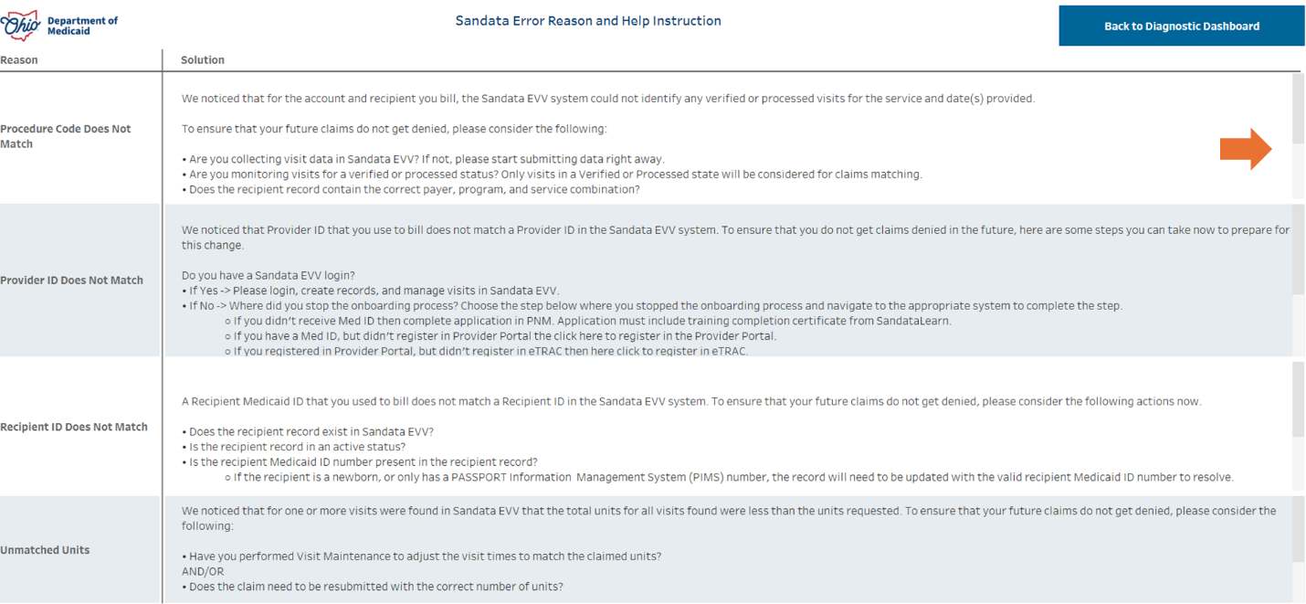
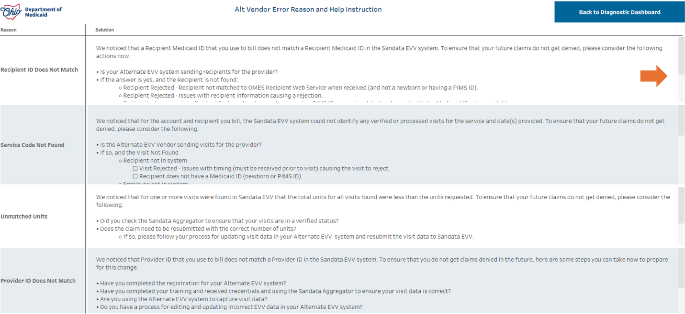
Additional Features to Note:
- You can utilize the navigation buttons on the dashboard to return to the home page (yellow arrow), navigate to the definitions page (orange arrow), or return to the SFY25 provider lookup dashboard (black arrow).
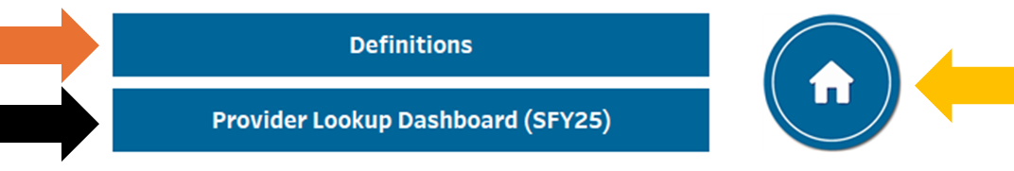
- Click the book icon, indicated by the orange arrow in the below screenshot, to navigate to additional EVV help information on the Ohio Department of Medicaid website.
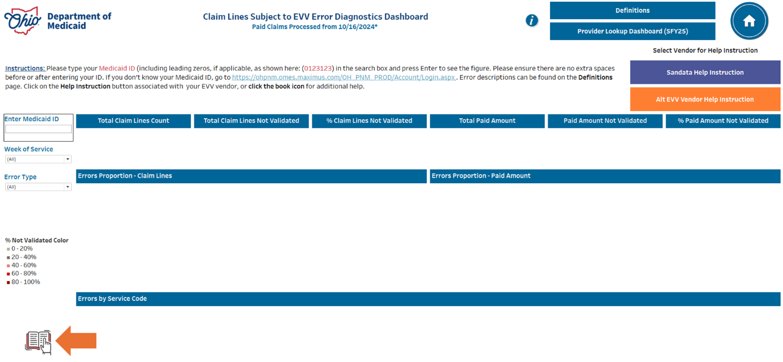

We recommend reviewing the dashboards at least once a month. If you have questions, please contact Sandata’s EVV Provider Hotline at 855-805-3505 so we can help. Office hours are also available for you to stop in for 1:1 assistance. Office hours are available daily at SandataLearn.com. Simply login in or register at SandataLearn and then click the Events tab to access Office Hours. You can also register directly here: Sandata Office Hours Registration.

